Consent Form for the use of photographs, videos, audio clips

Children’s permission 2020
Children should always be consulted about the use of their image and give consent to it being used and shared. Support children to be aware that a photo or video is being taken.
Adults should use this form to ask children how they feel about their image being used and explain what the image is going to be used for. Ask for their consent to share their image and record this here.

Evidence YES NO

Take photographs of me at active play
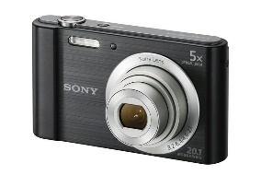 **

Video what I do and say
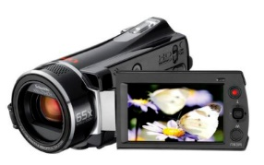 **

The following box is to be filled in by an adult
Child’s Initial
Name of Service:
Address of Service:

Manager Signature Dated:

**N.B. It is important to ensure that parents’ have already signed consent forms for photographs and videos before asking the child’s permission. Please attach this child’s permission to the Parental Consent form

